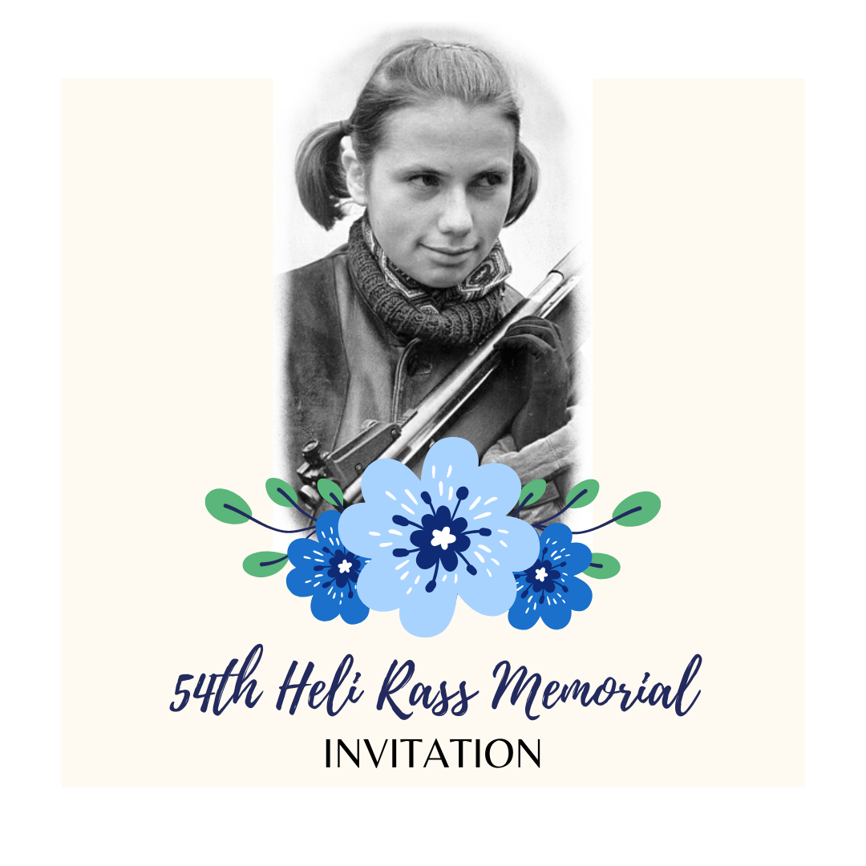
Dear shooters and coaches

Elva Shooting Sport Club and competition organizing committee invites you all to the beloved international shooting competition – 54th Heli Rass Memorial from 24th-26th April 2026 in Tartu County Health Sports Center!

Heli Rass was a young talented shooter from Elva who died at the age of 21, having by that time become the best female rifle shooter in Estonia, setting Estonian records and winning title competitions. In her memory and honour, memorial competitions have been organized in Elva since 1973, and they have become the opening competitions of the firearms season of Estonian shooting sports.

Please see the competition general information and schedule below. For registering your entries, please use official entry form given by the organizers and send it to elvalask@gmail.com.

Elva Shooting Sport Club
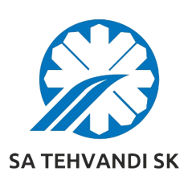
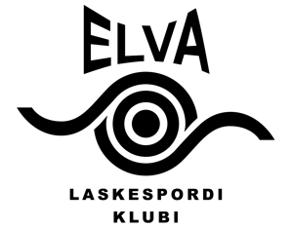

54th International Heli Rass Memorial

Tartu County Health Sports Center, Elva, Estonia

24th – 26th April 2026

GENERAL INFORMATION

SCHEDULE
Friday, 24.04.2026
12:00 Opening ceremony
13:00 25 m military rapid-fire pistol 3x20 shots (M, cal .32), (W, cal .22)
10 m air pistol, air rifle 60 shots (WJ, MJ) (Sius)
15:00 50 m pistol 60 shots Open (M, W) and Open Junior (MJ, WJ) (Sius)

Saturday, 25.04.2026
9:00 10 m air pistol, air rifle 60 shots (WJ, MJ) (Sius)
25 m standard pistol 20+20+20 shots (M, MJ, W, WJ)
10:00 50 m rifle prone 60 shots (W, WJ) (Sius)
50 m running target 30+30 shots (M, W)
12:00 25 m rapid fire pistol 30+30 shots (M, MJ)
13:00 50 m rifle 3x20 shots (M, MJ) (Sius)
17:00 50 m rifle final (M, MJ) (Sius)
18:00 25 m rapid fire pistol final (M, MJ)
20:00 Awarding ceremony

Sunday, 26.04.2026
9:00 10 m air pistol, air rifle 60 shots (W, WJ) (Sius)
25 m pistol 30+30 shots (W, WJ, MJ)
25 m centre fire pistol 30+30 shots Open (M, W)
50 m rifle prone 60 shots (M, MJ) (Sius)
50 m running target 20+20 shots mix (M, W)
12:00 50 m rifle 3x20 shots (W, WJ) (Sius)
16:00 25 m pistol final (W, WJ)
50 m rifle final (W, WJ) (Sius)
17:30 Awarding and closing ceremony
The times indicate the start of the competition shooting. The exact schedule and relies will be published on April 21. There are 8 places on the 10 m range. Both air rifle events are open to male and female juniors, shooting on any day of their choice throughout the competition.
RESULTS
Records shall be kept separately for women, men, junior female and junior male (born 2005 and later) age classes. Open event is individual event with male and female athletes competing together in one event. The same applies for Open Junior event, where junior men and junior women athletes are competing individual together in one event. Finals will be held for adults and including juniors as well. In case some of the finalists cannot participate in the final, next shooter from qualification ranking will be called.

AWARDS
Three bests from each event in adult and junior age categories will be awarded with competition trophy and diploma. Three bests of the finals will be awarded with special prizes from our sponsors. Two shooters – best female rifle shooter and best result shooter – will be awarded with the traveling trophy and special prizes from our sponsors.
Please be notified, that if the winners themselves are not participating in the award ceremonies, organizers have the right not to award them with special prizes from the sponsors.

The traveling trophies statute:
With the traveling trophy “The best women rifle shooter”, issued in 1973 by the Heli Rass´s parents, will be granted to the best female rifle shooter who obtains the best summary of two small-bore rifle qualification scores (without finals score).
With the traveling trophy “The best result”, issued by the Tartu District Physical culture and Sports Committee in 1973, will be granted to the shooter who obtains the best result in the competition according to the official shooting sport level norms.

MANAGEMENT
All travel, entry fees and accommodation expenses shall be paid by the participants.
Catering is available during the competition, payment in cash only.

ENTRY FEES
20 euros per exercise, also valid for exercises where parallel results calculation is held for the Baltic Cup. Payment can be made in cash at the secretariat or by bank transfer based on the invoice.

PRELIMINARY ENTRIES
Not later than 13th of April 2026 by e-mail: elvalask@gmail.com
Please use the official entry form given by the organizers.

INFORMATION
Karl Kontor, +372 505 4006
Marianne Tavits, +372 5569 7021
Lennart Saarepuu, +372 5361 0785
elvalask@gmail.com or www.elvalask.ee

ACCOMODATION BOOKING
Tartu County Health Sports Center:
Phone: +372 745 6333 or mobile +372 555 12 492, Website: www.tervisesport.ee

