INVITATION  to the 15th Ilgonis Freimanis memorial competition  20th - 22nd September, 2024  Dobele shooting range, Īles street 1, Latvia | 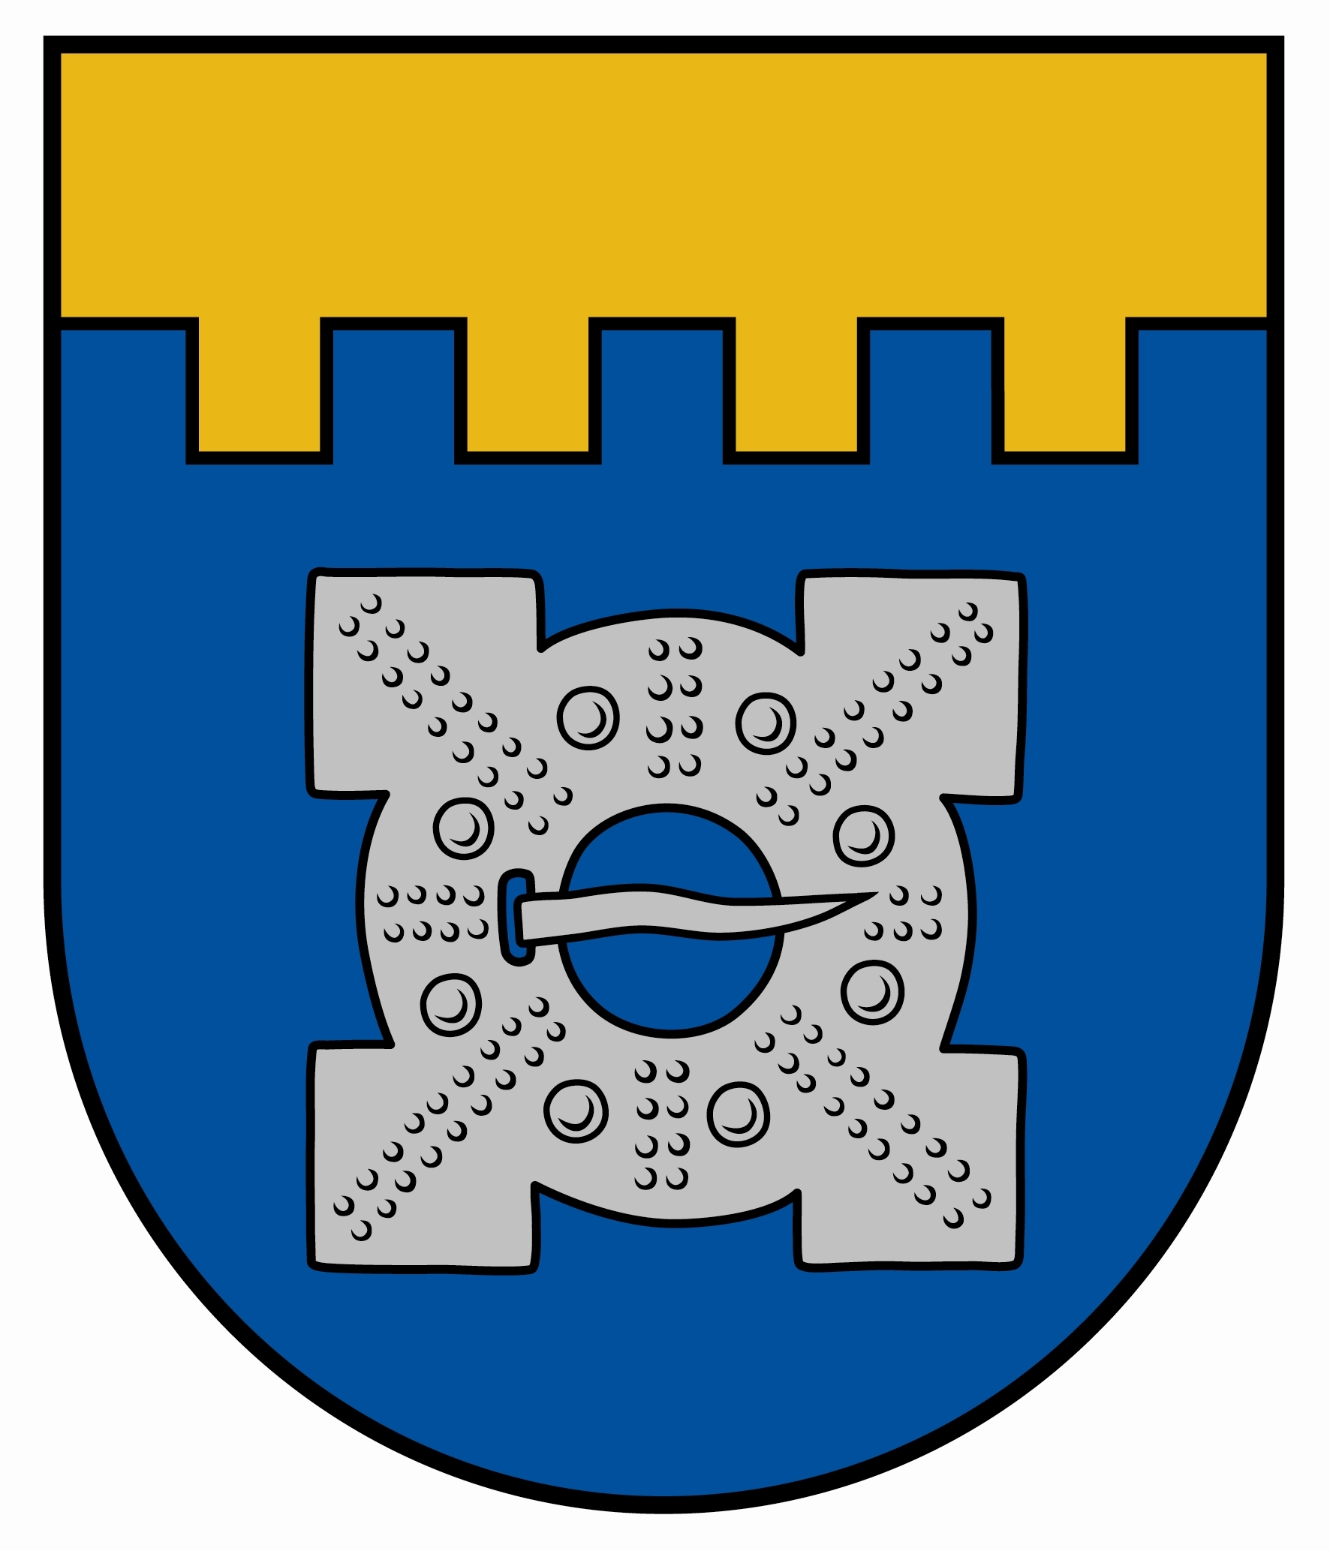

Organizers
The 15th Ilgonis Freimanis memorial competition will be organized by Dobele shooting sport club with a support of Dobele municipality.

Athletes
Athletes from Latvian shooting clubs and foreign countries – Estonia and Lithuania, Poland, and other countries are invited to participate in the competition. Athletes born before year 2010 are welcome to participate in the competition.

Program
The competition will be organized in women (W) and men (M) groups in pistol and rifle events.

20th of September
Arrival of the foreign teams.

21st of September
Women’s events:
10 m air rifle 60 shots
25 m sport pistol 30+30 shots
Men’s events:
10 m air rifle 60 shots
25 m sport pistol 30+30 shots
There will be final for air rifle shooters. In the final will shoot 16 best air rifle shooters irrespective of age and sex.

22nd of September
Women’s events:
50 m rifle prone 60 shots
10 m air pistol 60 shots
Men’s events:
50 m rifle prone 60 shots
10 m air pistol 60 shots
There will be final for air pistol shooters. In the final will shoot 16 best air pistol shooters irrespective of age and sex.

Evaluating
There is only individual competition in each event in women and men groups. 1st place holders/final winners in events “10 m air pistol” and “10 m air rifle” will be awarded with a cup. Best result holder in 60 shoots prone (no final) will be awarded with a cup. In other events the 1st, 2nd and 3rd place will be awarded with medal and diploma.

Finance
Entry fee is 20,00 EUR per athlete. All the other costs, such as traveling, customs and accommodation, on the person’s/entity’s account, which appoints and sends the athlete to the competition.

Application
Please let us know of your intended participation until the 10th of September to vilnis67@inbox.lv or armandsf@inbox.lv. Precise entry form (in appendix) should be sent to previously mentioned e-mail until the 15th of September, 2024.
All information about the lodging during the competition and answers to other questions you can get calling to Vilnis Celmiņš, cell phone 00 371 29 153 355 or Armands Freimanis, cell phone 00 371 29 241 948. At the competition place there is cafeteria.

Looking forward to see You in Dobele!

Vilnis Celmiņš
President of Dobele shooting club
Participants’ entry form
for the 15th Ilgonis Freimanis memorial competition
20th -22nd of September, 2024, Dobele, Latvia

^{(country, team)}

No. | Name, family name | Year of birth | 50 m rifle prone 60 shots | 10 m air rifle 60 shots | 10 m air pistol 60 shots | 25 m sport pistol 30+30 shots | Signature for safety rules in the shooting competition | Notes

Please return before 10th of September to vilnis67@inbox.lv or armandsf@inbox.lv

