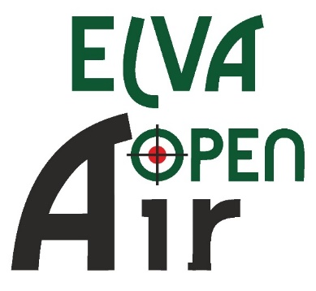

SCHEDULE

THURSDAY 12.01.
Arrival of Delegations

14:00 - 19:00
Equipment Control

14:00 - 19:00
Unofficial Training

19:30
Technical Meeting

FRIDAY 13.01.

07:00 - 18:00
Equipment Control

08:00 - 09:15
10m Air Pistol MJ / Air rifle MJ 60 shots I relay

09:45 – 11:00
10m Air Pistol MJ, WJ /Air rifle MJ, WJ 60 shots II relay

11:30 - 12:45
10m Air Pistol WJ, W /Air rifle WJ, W 60 shots III relay

13:15 - 14:30
10m Air Pistol W, M /Air rifle W, M 60 shots IV relay

15.00 – 16:15
10m Air Pistol M, /Air rifle M, 60 shots V relay

Finals

12.00 – 12.40 Final Hall
AP MJ + AC

13.20.-14.00 Final Hall
AR MJ + AC

14.30.-15.10 Final Hall
AP WJ + AC

15.40-16.20 Final Hall
AR WJ + AC

17.00 – 17.40 Main Hall
AP W, AR W + AC

18.20 -19.00 Main Hall
AP M / AR M + AC

20.00 -22.00 Banquet for representatives and coaches

SATURDAY 14.01.

07:00 - 19:00
Equipment Control

08:00 - 09:15
10m Air Pistol/Air rifle 60 shots I relay

09:45 – 11:00
10m Air Pistol/Air rifle 60 shots II relay

11:30 - 12:45
10m Air Pistol /Air rifle 60 shots III relay

13:15 - 14:30
10m Air Pistol /Air rifle 60 shots IV relay

15.00 – 16:15
10m Air Pistol /Air rifle 60 shots V relay

SUPERFINALS

18:00 – 18:20 Ranking Match 10m Air Pistol

18.25 – 18.40
Gold Medal Match Air Pistol

19:15 – 19:35
Ranking Match 10m Air Rifle

19:40 – 20:00
Gold Medal Match Air Rifle

20:15 Award Ceremony

SUNDAY 15.01.

07:30 - 14:30
Equipment Control

08:30 – 09:00
10m Air Rifle/Air Pistol Mixed Team J I relay

09:35 – 10:05
10m Air Rifle/Air Pistol Mixed Team J II relay

10:40 – 11:10
10m Air Rifle/Air Pistol Mixed Team S III relay

11:45 – 12:15
10m Air Rifle/Air Pistol Mixed Team S IV relay

Finals

11.00 – 11.20 Final Hall
Bronze Medal Matches 10m Air Pistol Mixed Team J

11:30 – 11:50 Final Hall
Gold Medal Match 10m Air Pistol Mixed Team J + Award Ceremony

12.30 – 12.50 Final Hall
Bronze Medal Matches 10m Air Rifle Mixed Team J

13:00 – 13:20 Final Hall
Gold Medal Match 10m Air Rifle Mixed Team J + Award Ceremony

13.00 – 13.20 Main Hall
Bronze Medal Matches 10m Air Pistol Mixed Team J

13.30 – 13.50 Main Hall
Gold Medal Match 10m Air Pistol Mixed Team S + Award Ceremony

14.30 – 14.50 Main Hall
Bronze Medal Matches 10m Air Rifle Mixed Team S

15.00 – 15.20 Main Hall
Gold Medal Match 10m Air Rifle Mixed Team S

15.30 Awarding and Closing Ceremony

Departure of Delegations

